COMPONENT LIST

- 2 Arduino UNO R3 Microcontrollers
- 4 DC Motors with Encoders
- 4 DC Motors
- 1 Pushbutton
- 3 L293D Motor Drivers
- 1 HC-SR04 Ultrasonic Distance Sensor
- 2 9V NiMH Rechargeable Battery Packs
- Jumper Wires

POWER CALCULATIONS

Power in this circuit is consumed by the 8 motor and the HC-SR04 distance sensor, 3 motor drivers and the 2 Arduinos

Power for motors :
Assumption : Since the L293D motor driver produces an output of 600mA under normal conditions, we shall assume motors take that as an input current to motors, let the operating voltage of motors be 9V, so power each of the motor consumes is 600mA*9V=5.4W

Due to 8 motors being present, the total power becomes 5.4*8
43.2W

Power for motor drivers:
Since the motor driver transfers most of its energy to the motors, the unaccounted energy in it is the one used to power the logic pins.
(https://www.edaboard.com/threads/l293d-consumes-so-much-current.52011/) 40mA is used for this purposes.

Since the input voltage is 9V
Power consumed per motor driver = 9V * 40mA=0.36W

For 3 motor drivers =3*0.36W

1.08W
2 Arduinos:

The Arduino transfers its energy to the rest of the circuit. It takes, say 100mA from power source https://www.microcontrollertips.com/how-to-optimize-arduino-for-low-power-design/
Let there be a 9V source powering the arduino
Power consumed per arduino : 9V*100mA =0.9W

For 2 Arduinos :

1.8W

For HC-SR04 ultrasonic sensor
https://cdn.sparkfun.com/datasheets/Sensors/Proximity/HCSR04.pdf
9V battery source and uses 15mA current
Power consumed =9V*15mA =
0.135W

Total Power consumed : 43.2W + 1.08W + 1.8W+0.135W =
Total Power consumed = 46.125
PCB TRACK WIDTH CALCULATION

Formula to calculate Track width : (KiCads calculator)

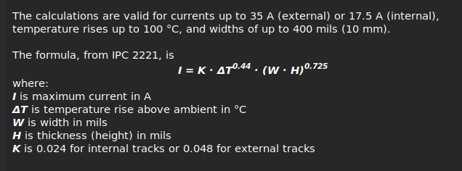
Since we are dealing with external tracks, K=0.024
And delta T has been kept to the standard value of 10 degrees Kelvin, and H(thickness) to be the standard value of 1 oz/ft^2

Default signal lines : Carry maximum 600mA current(used by motors)

Thus the formula gives the trace width to be 0.15 mm

Power signal lines : The current coming from the 9V battery is 600mA * 4 (4 motors) =2.4A, which is the maximum current flowing through any track

Thus the formula gives the trace width to be 1.00 mm

